CHECK YOUR PIPES!

Enter this link into your web browser:

https://toa-iwjlo.formstack.com/forms/water

or click the QR code below with your phone camera:

What is the Ashford's 'CHECK YOUR PIPES' initiative?
As part of new regulations developed by the Environmental Protection Agency, the Town of Ashford is required to collect an inventory of water service line materials to each customer throughout The West Valley Water District water system. We need your help to accomplish this task!

How to Identify Your Water Service Line Material
Please use the following steps below to help identify the material of the water service line entering your home or business:

Step 1
Locate the water pipe where it comes into your house through the foundation (as indicated by the red arrow in the picture below). 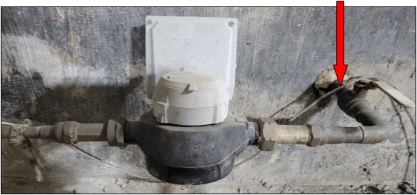

Step 2
Identify the material of this pipe using the following guide

Water Service Material Identification Guide
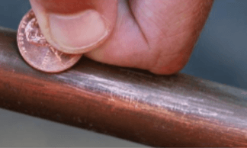
You will need a MAGNET and a COIN (preferably a penny).

Copper Pipe
- Scratch the pipe with a penny. If the scraped area is copper in color, like the penny, the service line is copper.
- A magnet will NOT stick to copper pipe.

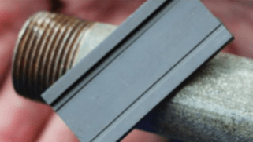
Galvanized Iron Pipe
- Pipe is dull, silver-grey in color.
- If a magnet sticks to the surface, the service line is galvanized iron.

Lead Pipe
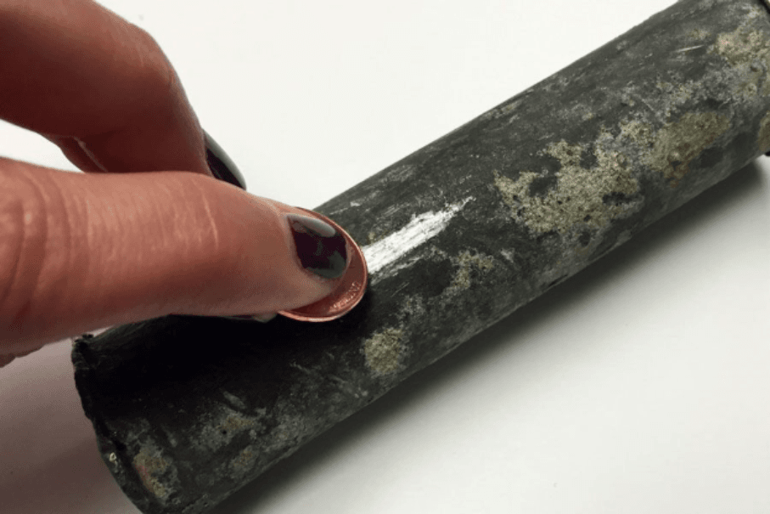
- Pipe is dull, silver-grey in color and is easily scratched with a coin.
- A magnet will NOT stick to lead pipe.

Report Your Findings
Once you have determined the material of your water service line using the steps above, please fill out our online survey by clicking on the link at the top of this page.
If you are unsure or unable to identify the material of your water pipe, you may take a picture of the pipe and attach it to the online survey. Please make sure the picture is as clear as possible and includes the water meter.
If further investigation is required, a Town of Ashford representative will contact you to set up an appointment to verify the service line material at your convenience.

THANK YOU FOR YOUR HELP!

