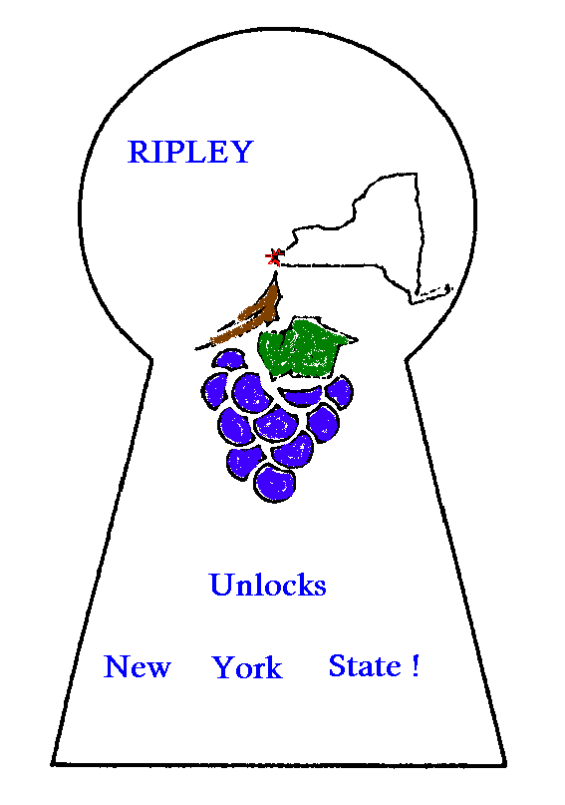

Community Forum
A Discussion with the Chautauqua County Sheriff’s Office
Wednesday, April 17, 2024
Ripley Public Library
6:30PM

Due to the recent events in our community, the Ripley Town Board has arranged for a community forum and discussion with representatives from the Chautauqua County Sheriff’s Department.

Community members are encouraged to attend to ask questions and voice their concerns while also learning how we can work together to keep our community safe.

