Town of New Albion
7151 Route 353
Cattaraugus, NY 14719
Regular Board Meeting
March 18, 2024, 7:00 p.m.

PRESIDING: Patrick Murphy, Supervisor

PRESENT: Councilmen: Cynthia Eaton; Michael Weishan; Norman Kazmark; Daniel Goss; George Borrowdale, Highway Superintendent; Frank Watson, Code Enforcer; and Sherry Rupp, Town Clerk.

VISITORS: Brandon Sawyer, Resident.

CALL TO ORDER: Supervisor Murphy called the meeting to order at 7:00 pm. Followed by the Pledge to the American Flag. Regular Minutes for February 19, 2024. Town Clerk Monthly Report, and the Register’s Report were all approved as presented by the Clerk.

CORRESPONDENCE:

- Southern Tier West Newsletter March 2024
- AOT – Impact on Towns Funding
- Et cetera March 2024

VISITOR: Brandon Sawyer is petitioning the Town to have his parcel re-zoned from General Business to Agricultural/Forestry. He considers himself and his daily operations as a farm. The Board has Tabled this until our next meeting.

REPORTS:

Code Enforcer: Frank Watson, Permits are light. There is a Variance (Setback for pole barn on New Albion Rd.). There are 3 Appearance Tickets going in front of the court tomorrow.

Highway Dept.: George Borrowdale, First, I want to address work zones and the need to stop traffic is for the Safety of our workers and the traveling public. No spinning of tires. And No speeding through passed workers. I also want to let the board and town residents know if they have a problem with what the highway crew is doing, they are to direct their anger and criticism to me, not our employees. Gowin Gulf Rd. culvert/bridge has been rated at 8-ton Max. Catt. Co. Engineers agreed that the 5-ton limit we put on was fine to leave in place. I have temporary easement from property owners of 78 Jefferson St. to move equipment into stream and redirect water to stop the erosion to their yard and bridge foundation. Waiting to hear exactly what we can do and what we cannot do in stream bed. We have been trimming branches and cleaning up brush mostly on Scott Hollow Rd. preparing for paving project this summer. Replacing a sluice pipe also be done before the paving project begins. Will notify residents of date. Our standby generator has been installed and already used twice. Will be installing thumb attachment on excavator for placement of rocks and picking up debris. I would like to repair or replace our Town of New Albion sign. Need to order more salt to fulfill our contract. Approx. 83-tons Owner purchased sluice pipe for driveway on Potter Hill Rd. not sure when we will be installing.

Treasurer: Eugene Doucette, Expenditure Report & Revenue Report

Assessor: Elizabeth Lerow, the February report is as follows:

- Because exemption renewal applications are due March 1, February is always one of our busiest months answering taxpayer questions, processing applications, contracting applicants for additional information, etc. In order to best serve these applicants, we also take time to call those who have not returned sufficient backup with their renewal applications. Reminder letters were sent on February 1st to all applicants whose application had not yet been received.
- Renewal applications for Agricultural Assessment and Senior Citizen Exemption are being submitted and processed. So far, 94% of Agricultural Assessment and 90% of Senior Citizen renewal applications have been processed.
- The Assessing Office has corresponded with several property owners about their assessments, tax bills, and exemptions.
- There were eight property transfers in January. You can find more information about these sales here: https://www.cattco.org/real-property-and-gis/sales

Board:
Councilman Patrick Murphy – None
Councilman Norman Kazmark – Has concerns regarding potholes on Snyder and Scott Hollow Rd.
Councilman Daniel Goss – None
Councilman Cynthia Eaton – None
Councilman Michael Weishan – None

CLERKS REPORT:
Clerk Report: February 2024, Amount Collected $ 335.00
Animal Population Control: Check # 2752 - $ 39.00
Town of New Albion: Check # 2753 - $296.00
Amount Paid Out $ 335.00

- Murphy Award Flyers were placed at the following locations: Post Office, Bank of Cattaraugus, Jenny Lees, Village Hall, and Town Hall. Nominations will be announced at our April 15th Meeting.
- I recently attended a Notary Academy. It was a wonderful class to attend.
I will be attending a Town Clerks Conference from April 21- April 24th in Albany.
- Regarding Waverly St. Our attorney notified the town on 3/8/24 that the mediation that was scheduled for March 22nd has been cancelled due to a conflict arising for council for Wendel Engineering. The rescheduled date should be sometime in April.
- As for Jefferson St. on 3/12/24 we received our Second Appeal Determination for a Time Extension on PW552-we were Denied. The decision is Final. I’m preparing the Quarterly Report for this project.

- Ambulance District-moving forward.

Resolution # 23- 2024– Adopt Order for Ambulance District
On a motion by Councilman Weishan, seconded by Councilman Eaton, the following resolution was

ADOPTED Aye 5 Weishan, Eaton, Kazmark, Goss, and Murphy
Nay 0

RESOLVED, approved to adopt ORDER.
Order

The Town Board of the Town of New Albion hereby ORDERS as follows:

The description of the boundaries of the proposed ambulance district shall be:

All of the Town of New Albion, Cattaraugus County, New York including the Village of Cattaraugus.

The maximum estimated amount in the future years, proposed to be expended annually by the Town for such ambulance services paid for by raising taxes in the ambulance district, shall be $66,480, which would impose a tax of $45.16 for the owner of a property in the Town valued fully at $100,000. This rate reflects the ambulance district encompassing the entire Town of New Albion and the Village of Cattaraugus.

A map, plan and report describing the proposed ambulance district shall be placed on file in the Town of New Albion Town Clerk’s office for public inspection. The Clerk of the Town of New Albion shall provide the public notice of a public hearing where all people interested in the proposed ambulance district can be heard. Such hearing shall be held on the 15th day of April 2024 at 6:30pm in the Town of New Albion, at the street address as follows: 7151 Route 353, Cattaraugus, NY 14719.

This order shall be published at least once in the official paper, the first publication thereof to be not less than ten (10) nor more than twenty (20) days before the day set therein for the hearing as aforesaid, and shall also cause a copy of this order to be posted on the sign-board of the Town of New Albion maintained pursuant to subdivision six of section thirty of the Town Law.
This constitutes the Order of the Town Noard of the Town of New Albion, Cattaraugus County.

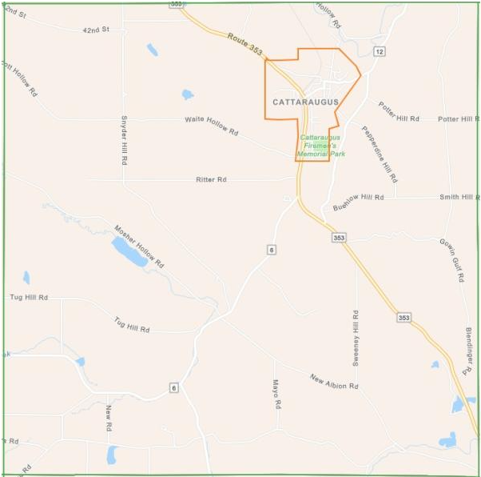

- Last month the Board approved to use ARPA Funds to purchase the Generac Generator.

Resolution # 24- 2024 – Transfer Funds
On a motion by Councilman Eaton, seconded by Councilman Goss, the following resolution was

ADOPTED Aye 5 Weishan, Eaton, Kazmark, Goss, and Murphy
Nay 0

RESOLVED, approved to transfer $12,200 from the ARPA account to the Building Account 1620.4 for the Generac Generator.

Resolution # 25- 2024 – Transfer of Funds
On a motion by Councilman Weishan, seconded by Councilman Eaton, the following resolution was

ADOPTED Aye 5 Weishan, Eaton, Kazmark, Goss, and Murphy
Nay 0

RESOLVED, approved, to transfer $50,000.00 from Highway Townwide (DA) Savings Account to Highway Townwide (DA) Checking.

Resolution # 26- 2024 – Transfer of Funds
On a motion by Councilman Weishan, seconded by Councilman Eaton, the following resolution was

ADOPTED Aye 5 Weishan, Eaton, Kazmark, Goss, and Murphy
Nay 0

RESOLVED, approved, to transfer $20,000.00 from General Townwide Savings Account to General Townwide Checking.

OLD BUSINESS:

- Hazard Mitigation Project

NEW BUSINESS:

- Ambulance District
- Richard L. Murphy Citizenship Award 2024
- Cattaraugus Fireman’s Installation Banquet
- Abstract #3– March 18, 2024 / Pay the Bills

APPROVAL OF ABSTRACT:

Resolution # 27- 2024– Abstract # 3- 2024– March 18, 2024
On a motion by Councilman Eaton, seconded by Councilman Kazmark, the following resolution was

ADOPTED Aye 5 Weishan, Eaton, Kazmark, Goss, and Murphy
Nay 0

RESOLVED, that Abstract # 3 -2024 in the following amounts is to be paid.

ACCOUNT VOUCHER # TOTAL EXPENDITURES
General A 12912-12941 $ 28,390.55
General B 1007-1009 $ 936.74
Highway DA 9667-9674 $ 67,083.00
Highway DB 3852-3856 $ 11,782.08

With no further business to discuss, the meeting was adjourned at 8:34 pm.

Respectfully submitted,

Sherry Rupp
Recording Secretary
Town of New Albion Town Council

Next Meeting: Regular Board Meeting April 15, 2024

