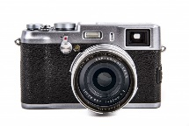
We want your pics!
The Village of Wellsville is looking for pictures of the Village to feature on the Village website.
The pictures should incorporate the beauty and hometown feel while integrating the local downtown businesses, parks and other local highlights.
Multiple pictures can be submitted.
Please fill out the following form, attach a copy of your photo and send to the address below before February 28:
Village of Wellsville, 23 N. Main Street, Wellsville NY 14895.

The winning photos will be announced at the
March 13 Village Board meeting.

*All photos must be taken by the individual named above
*Check out the Village website at: www.wellsvilleny.com
*Forms can be found on the website or at the Municipal Building located at 23 North Main Street, Wellsville, NY.

Name:
Address:
Phone number and/or email:
Brief photo description:
Approximate date and location the photo was taken:

