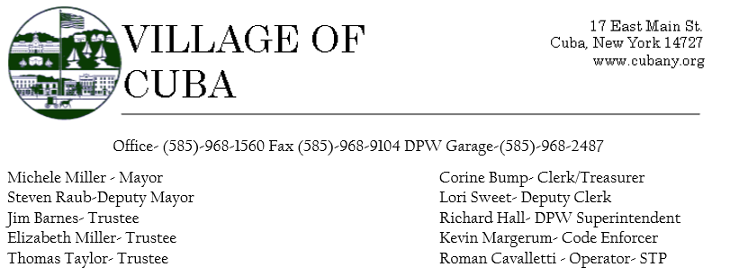
PRESENT: Mayor Michele Miller, Trustees Tom Taylor, Jim Barnes, Elizabeth Miller, Steve Raub
ALSO, PRESENT: Corine Bump, Clerk/ Treasurer, Richard Hall DPW Superintendent, Roman Cavalletti- Deputy Clerk Sweet was covering the telephones and counter during the meeting.
GUESTS: N/A
TRUSTEE BARNES MADE A MOTION TO ADVERTISE A CONTRACT TO COLLECT REFUSE AND RECYCLING WITH TRUSTEE RAUB OFFERING A SECOND. ALL IN FAVOR AND THE MOTION CARRIED.
OLD BUSINESS: N/A
NEW BUSINESS: The Board worked towards the Fiscal Year budget 2022-2023. While the workshop was very productive, The Board will meet again 3/16/2022 at 2:30p.m. to discuss a few more scenarios to work towards a definitive budget.
Respectfully Submitted,
Corine Bump
Clerk/ Treasurer

