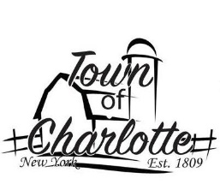 TOWN OF CHARLOTTE
2023 TOWN BOARD MEETINGS
ALL MEETING START AT 7:00 PM
Sinclairville Volunteer Fire Dept Town Highway Garage
30 Main St., Sinclairville 7059 Rood Rd., Sinclairville

February 8 April 12
March 8 May 10
June 14
November 1 July 12
December 13 august 9 September 13
October 4

