Office- (585)-968-1560 Fax (585)-968-9104 DPW Garage-(585)-968-2487 TDD/711
Michele Miller - Mayor Corine Bump- Clerk/Treasurer Steven Raub-Deputy Mayor Lori Sweet- Deputy Clerk Jim Barnes- Trustee Richard Hall- DPW Superintendent Elizabeth Miller- Trustee Kevin Margerum- Code Enforcer Thomas Taylor- Trustee Roman Cavalletti - Operator- STP

8/10/2022 Village of Cuba, NY BOARD OF TRUSTEES MONTHLY MEETING & PUBLIC HEARING at 17 East Main St. Cuba, NY 14727
PRESENT: Mayor Michele Miller, Trustee Steve Raub, Trustee Tom Taylor, Trustee Jim Barnes
ALSO, PRESENT: Corine Bump Clerk/ Treasurer, Rick Hall- Department of Public Works Superintendent, Kristopher Krzos Assistant Superintendent of DPW, Operator STP Roman Cavalletti, Residents- Cindy Colley, Sue Taylor, Janet Nolan, Colin DeKay- Casella.
EXCUSED: Elizabeth Miller
MAYOR MILLER opened the August monthly meeting with the Pledge to the flag.
One sealed billed was dropped of at the Clerk’s Office on Monday August 8, 2022 around 8:30 a.m. marked received by L Sweet Deputy Clerk Treasurer pertaining to the Refuse RFP that was advertised. The bid was opened by Trustee Taylor and was submitted by Casella and handed it to Mayor Miller.
Mayor Miller reviewed the submitted bid- presented in three ways as follows
2.2.1 Contractor will provide all labor, material, and equipment to collect and dispose of solid waste, garbage, trash, refuse, waster material and recyclables from all residential and non- residential units within the Village of Cuba in accordance with the attached specification- For the contract term specific date to be determined - $180,105.60
Alternate Number 1- All solid waste items to be collected as specified except for One Bulk item per week (3.1.14) In this alternate, one bulk item per week will be replaced with two bulk items per month. -$170,105.60.
Alternate Number 2- All solid waste items to be collected as specified, except for the Contractor supplying 96-gallon bins for solid waste and recyclables. -$189,156.00 Complete bid proposal on file at the Village of Cuba, NY Office.

Discussion took place with Colin DeKay to help clarify some questions. Trustee Taylor and Trustee Barnes asked for a special Board Meeting on Wednesday 8/14/2022 at 1:00 pm. Clerk Treasurer Bump will send notification to the website and the newspaper in addition to posting around the town of the meeting.
MINUTES: TRUSTEE S. RAUB MADE A MOTION TO APPROVE THE MINUTES WITH TRUSTEE J. BARNES OFFERING A SECOND. ALL IN FAVOR AND THE MINUTES WERE APPROVED.
APPROVAL OF CLAIMS AND BILL PAYMENT:
BILLS: Clerk Bump discussed the budget line G008130-45 purification contractual. The UV bulbs were ordered in April FY 21.22- however did not arrive until the first week of August FY 22.23. There was mention at a previous meeting, there might be a need to encumber the funds from the 21.22 FY budget, no further action was made, therefor to pay the bill properly an amendment to the appropriated line is needed. The 21.22 year had a budget of $14,000 in said line and it was reduced to $3,000 at budget time. Enough bulbs were purchased to include last fiscal year and this fiscal year’s need.
TRUSTEE RAUB MADE A MOTION TO AMMEND THE 22.23 FY YEAR BUDGET- LINE G008130-45 USING $2,482.21 OF SEWER FUND BALANCE WITH TRUSTEE TAYLOR OFFERING A SECOND. ALL IN FAVOR AND THE MOTION CARRIED.
The bills were reviewed by Mayor Miller, Trustee Raub, and Trustee Taylor prior to tonight’s meeting.
TRUSTEE RAUB MADE A MOTION TO APPROVE THE BILLS WITH TRUSTEE TAYLOR OFFERING A SECOND. ALL IN FAVOR AND THE MOTION CARRIED.
Abstracts Voucher #’s 202300084-202300156
General Fund- A-$34,359.95, F$4,294.69, G$29,782.99 Total- $68,437.63
POLICE REPORT: Chief Burch Submitted an Excel Spreadsheet Report and it’s printed on file at the Clerk’s Office.
BUILDING INSP./CEO: Code Enforcement Report
Offered for Village Board Meeting of August 8, 2022

Project at Summit Ave. (single family dwelling)
The floor system is completely installed on the new foundation.

Project at Bull St. (pole-style storage building)
Vapor barrier is installed on the completed framing and windows have been installed

Project at Champlain (detached 2-story garage)
In-floor radiant heat tubing and required moisture barrier has been installed in the foundation area. This heating system had not been discussed as a component of the construction.

Project at Champlain. (Living area addition to a single-family dwelling)
Rough framing and rough electrical inspections have been completed. We will receive a call when the insulation has been installed. Roofing has also been completed.

Professional Services Building project (N. Water St.)
Installation of systems and mechanical equipment is moving along well and near completion. The builder has decided to seal the underside of the metal roof with closed cell, spray-on insulation following a brief stop work request by code enforcement for clarification of the building design. Changes by a sub-contractor to perform that task has resulted in a small delay. When the roof is “sealed”, interior insulation can be completed and installation of interior wall surfaces will begin.

Project at (Bristol St.)
The Engineer working on the project has determined that heat detectors may be used as a replacement for smoke detectors in non-sleeping areas. The smoke detectors in the hall (typical to all units) have been isolated as the main source of nuisance alarms. This has been a catching point for Code Enforcement, because heat detectors are not typically recognized for use in life-safety environments, rather, they are used to protect property and inventories.
I contacted Property Manager with this update so they can move ahead with needed changes.

WASTEWATER PLANT REPORT: Roman emailed his report to the board and presented-
Village Of Cuba WWTP Report
8-8-22
Roman Cavalletti

- The DMR for the month of June was sent in and all was within limits.
- On July 19th the South primary clarifier wiper arm broke off. Roman called Pierce Steel from Olean, NY and the sent someone right out to assess the problem. The said that they needed a platform built to work from and that they would come back to fix it the next day. With some help from the Village DPW crew we made a platform and Pierce Steel made the repair.
- The U.V. bulbs arrived the first week of August. The budget line is over and fund balance is needed to amend the budget to G008130*45 due to the timing of their arrival. No money was spent from the line in the last budget year.
- The Energy audit from Rural Water has been completed and is on file.
- Roman stated other equipment at the STP has been working well.

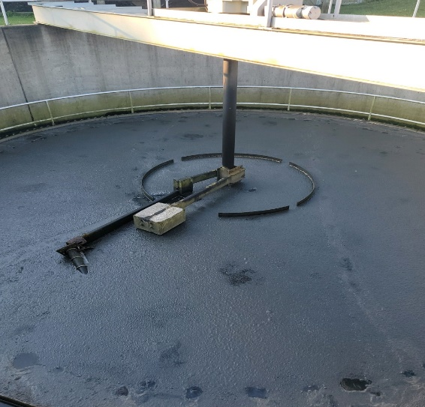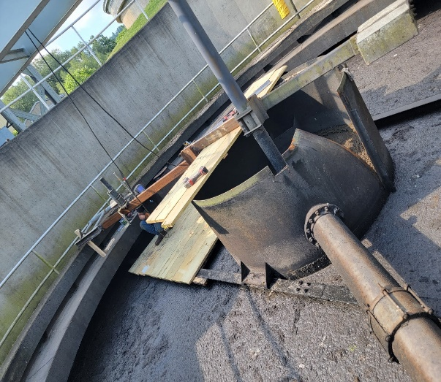

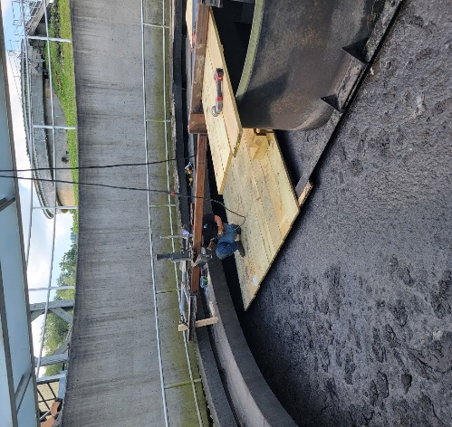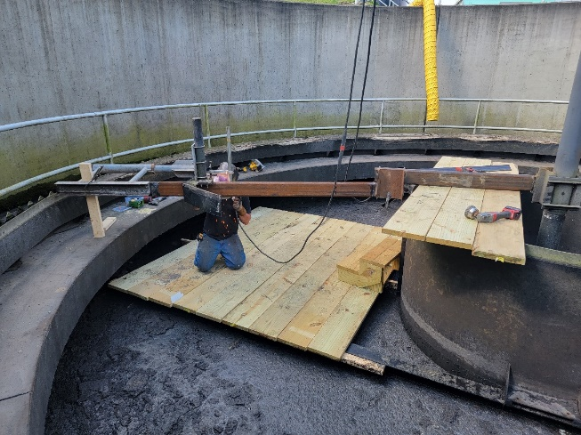

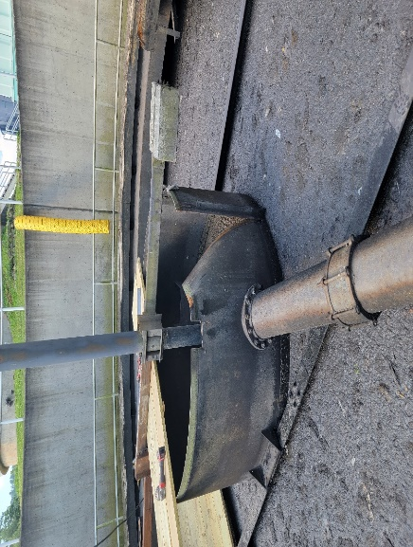
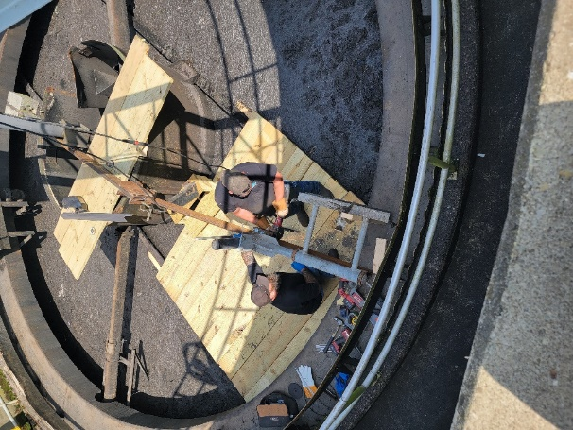

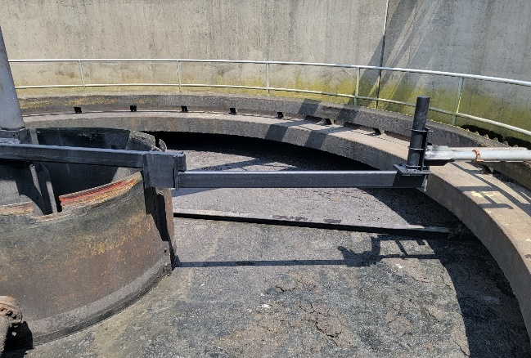

Trustee Taylor inquired about the INI grant/ The study is published and there are a few options for solutions to the decrease in kilowats used. The option that is most cost effective ironically is Option 2 the $7.2 million project. Discussion tabled at this time.

Village Board Meeting
Superintendent’s Report
August 8, 2022

- Monthly Water Test Results for E. coli/Coliform – Both “Negative.”
- Yearly mowing/weed eating at the landfill is done
- Helped NYSDOT pick up millings on Genesee St./Rt.305 N
- New flooring in men’s bathroom in Chamberlain Park
- Installed new sewer lateral and tapped the water main for services at #1 Summit Avenue (Alan Zayac)
- Dug out Three spots from previous water/sewer digs and filled with binder and top. (Orchard, S. Park & Grove)
- Worked on patching potholes
- Ditched from dentist office to Cummins Construction and installed sluice pipe for new driveway
- Finished drain line on Windsor Street
- Made permanent repair to gazebo lights
- Trimmed hedges around the gazebo
- Installed last “sitting bench” by Pa Ingalls Lane
- Removed sidewalk blocks for Ellen & Jerry Scott
- Poured concrete at 4 locations from leak repairs
- Helped Roman with skimmer arm repair in clarifier
- Picked up steel for pole barn, shop wall and ½ of shop ceiling
- Washed graffiti off W.B. basketball court
- Water issues: Service line leak @ 25 Champlain St., 6” water Main break on Genesee St. by Parkway (again ) Thank you to a couple special helpers: Oakley Sortore & Duane Hopkins!!
- Equipment Repairs: Finished reassembling leaf vac. Serviced the backhoe, Trucks #1 & #9. International dump truck got inspected. New front brake pads and rotors on the van. Sewer machine is not working. Thank you, Oakley Sortore, for letting us borrow yours!!

The sewer machine is not working. Superintendent Hall presented three quotes to the Board for a new machine as the third company was closing. Cyncon Equipment $75,390.00 March 2023 maybe for the 747 model. Joe Johnson equipment has one for $3,000 more with a delivery time of 90-100 days. The factory was contacted and if it gets ordered this week at $78,390.00 it will arrive in early November. Discussion took place regarding where the funds would come from and between the equipment line money that has not been spent in previous years, combining fund balance and ARPA money, the cost will be covered.

TRUSTEE BARNES MADE A MOTION TO PROCED WITH A PURCHASE FOR THE SEWER MACHINE FROM JOE JOHNSON EQUIMENT- VACTOR SEWER MACHINE RAMJET WITH A PLATFORM AND CAMERA WITH A SECOND BY TRUSTEE RAUB. ALL IN FAVOR AND THE MOTION CARRIED.
DPW Superintendent Hall said that Assistant Superintendent of Public Works Krzos (pronounced Cross) and he took the Sweeper to CYNCON in Rochester in the hopes of receiving a quote for several repairs necessary to keep the sweeper in use. It has not been working at capacity in several months. They will watch for an email with the quote. The new sweeper is still scheduled to be delivered next year 2023.
Trustee Barnes asked what the water is that has surfaced at the intersection at the four corners. DPW Super. Hall stated it was just a valve that needed fine tuned to shut off. No additional leak currently.
Discussion took place regarding the cameras at Willow Bank Park. They need replacing due to the poor quality and distance from where the vandalism is repeatedly occurring- the new cameras have higher pixels so it can better tell the image of the people. Three quotes were presented. Two businesses quoting a price said what Hall was asking for is not the correct equipment for the space, and Hall feels one quote from the other business may not be accurate- so the quotes are not “apples for apples”. F Schostick- $2,860.05, Jonathan Enzinna- (Southern Tier IT) $3,350.27, and Premier Communications-$4,328.00. One bid is for circuit cameras the other two are including a Wi-Fi bridge (wireless point to point). Clerk Bump asked if an internet connection is required at the Willow Bank Park because it is described to Superintendent Hall as the same kind of Cameras that are at Genesee Parkway using the same kind of signal the Chamber uses- which uses the internet from Genesee Parkway and the Chamber Office. It was clarified that independent internet is not needed; it is an independent part of the camera that shoots a signal to record activity. There is no internet access at Willow Bank currently. Hall stated it would use a signal like what the Chamber uses. Hall stated he will speak with F Schostick for clarification. Discussion tabled at this time.
DPW Super Hall wanted to extend his thanks to all in the community that brought the staff food and drinks during the long workday with the three water line breaks.
Mayor Miller spoke her thankfulness with the Board echoing the praises for all who worked on the three water leaks Friday 8/5/22 on Champlain Avenue, and two on State Rte. 305 by Genesee Parkway. She stated it was all hands-on deck and all available employees stayed the entire time, with one even headed back first thing in the morning after a 1:00 am finish time to check the wells and reservoir and the STP and she was thankful to the hard work and dedication displayed by the available DPW staff and two volunteers. Hall stated they were thankful for the community outreach that made a stressful, hot, soaking day, a success from all involved.
Cuba Village Summer Recreation Program 2022 Report:

Number of children who participated: 134 signed up and only a few of those didn’t attend the program at all. On average, we had about 76 kids per week. Our first week was the busiest, likely because Summer School hadn’t started, and we had around 100 kids that week.
Female: 65
Male: 69

Race:
White: 118
African-American: 11
Hispanic/Latino: 2
Asian: 3

Age:
0-4: 5
5-9: 70
10-14: 59
15-17: 0
Children of Incarcerated Parents: 0

Overview of summer:

Food Program: No Food Program, but we are hopeful to do it next year.

Employed: Our staff this year was Kyla Tronetti, Kirstyn Snyder, Seth Bogart, Ella Jaffe, Meghan O’Keefe, Lillian Forward, and Taylor Searle. Taylor was hired on as a substitute during the days the other employees took time off and that worked out well! Our staff this year was wonderful. A few were not sure if they would be able to apply next year due to possible internships with college, so I am hoping we can advertise more when we are hiring and get more applicants to choose from.

Special Days:
This year we continued the tradition of special days including Community Clean Up, Theater Thursday, Pet Day, Salon Day, and our Bike Rodeo. We also included weekly themes to base some crafts and activities on. Our themes were Outdoor Explorers, Blast From the Past, Kindness & Community, Magic & Mystery, Self Care, and Under the Sea. The kids and staff seemed to really enjoy the themes and activities that went with them! During Blast From the Past week, each day was a different decade (50’s day we had an ice cream social, 60’s day we made tie dyes, 70’s day we made disco balls). During Magic & Mystery week, we had a magician come to the park and host a Magic Class. Kids got to learn approximately six magic tricks and get props to take home with them to continue the magic. We were also able to make trips to the library each Monday, trips to Willowbank park each Wednesday, and trips to Rushford Beach each Friday. Having Rushford Beach trips on Friday was wonderful because the Summer School kids were able to be included and we had around 30-40 kids go each week.

Overall, this year was amazing! We couldn’t have asked for better weather, better staff, and a better season! Thank you so much for the generous budget and everything you allow us to do!

CLERK/TREASURER REPORT: 8/8/2022 Clerk Report

- The NYS 1, and the Retirement report all have been accepted and paid.
- We still have not received a paid in full receipt for the payoff of the water tank.
- Septage was invoiced for July 8/3/22.
- Worked with the LIHWAP Program and continue to refer people and receive payments.
- The Printer/ copier/ scanner/ fax machine came on Tuesday July 19.
- A TEAMSTERS rep. finally called us back returning several voicemails and emails since June regarding several staff/ CBA questions.
- Worked on several credit card issues with the Company again- The old card is attached to D Wilson former Clerk- Treasurer’s name and social. While her card was canceled when she retired, she is the only person that can fully cancel the account. Corine has contacted Mrs. Wilson by phone to let her know the Village will be cancelling the old cards that were opened and is mailing a letter also. Diane stated that she thought we had done that already (us too) and she will be glad to assist. A new card has been opened NOT TIED to any staff members social- only the Employer ID number.
- The NYS 45 was submitted to the County and NYS on Friday July 22 due to illness and still on time. The 941 was submitted the last week of July on time.
- Lori and Corine have been working to make some changes in the office to increase efficiency. The several decades of cords are rescheduled to be rerouted on Wednesday August 10 due to an unexpected timing of delivery to the contractor making the improvements.
- Corine has a NYS Clerk’s Association Meeting Thursday August 11 and Friday August 12th. The Clerk’s Association will pay Corine for the mileage and the hotel. The Village Clerk of Barker is meeting near Rochester to ride share with Corine and sharing a hotel room in Verona.
- We are working with the Village’s Insurance Company to utilize some mandatory Trainings they offer with our policy for all staff.
- There is a NYS Comptroller training on August 10th at 10:00 am Management's Responsibility for Internal Controls- Corine emailed the information to all the board members with the date and time.
- 3 staff and three board members have been out with Covid. All are back at it and the three staff members documentation is in their personnel files. Thankfully everyone is on the mend. Covid cleaning procedures are still in place in the Clerk’s Office.
- Mayor Miller, Corine, and Lori have been working to fulfill the required documentation for several grants awarded/ grant applications in process.
- Corine worked with Jim to get the RFP for refuse to the paper. Jim called Corine with two corrections requested after it was cleared and advertised by the lawyer to submit and printed and at Jim’s request Corine worked with the Times Herald and Southern Tier to get the corrections and notifications of corrections uploaded and sent.
- Corine and Lori worked with a staff to get their application and all required documentation submitted to sit for the 3A exam.
- Corine and Lori worked with Occustar, Jones Memorial Hospital, Allegany County, Sheridan Benefits, Teamsters, and Blue Collar to get the new staff requirements processing.
- I created Village of Cuba, NY emails for the two new staff. As an extra- I added all current full time staff members and Board of Trustees in their contact list. They were notified and their info is stored in their personnel file like all other staff.
- Village of Cuba, NY Policies pertaining to the new staff were provided as well as copies of other Village of Cuba, NY documents.
- Many thanks to Lori and Mayor Miller for their continued excellent collaboration while I worked from home as much possible while dealing with Covid. We were able to get all the new employees entered on the secure hard drive and processed even though we were not getting a response from another entity dealing with their payroll deductions. All required reports were submitted on time, and the office continued to operate as usual while we worked together during that time frame. I am very appreciative.
Clerk Bump noted a discussion with B&L regarding invoices for the INI study and the Water Improvement Project. A correcting entry to last year’s budget line G008130-4 needs to be made in the Financials due to an incorrect title on an invoice- the amount should have come out of the Water Improvement Project, not the INI Sewer Study- line. Clerk Bump reminded the board that the G008130-4 appropriation line shows being over budget for the FY ending May 31, 2022- however, with the reimbursement of the INI grant money of $10,800 and the correction to the line in the amount of $6,160.00, the balance is $1,153.73 in the black. This month two more invoices were submitted and are a total of $14,400.00 which will also be partially reimbursed by the INI grant awarded ($30,000.00). At this time, it looks as if the line is close to being over budget in only the third month of this fiscal year with a balance of $5,938.24 remaining, however once the grant reimbursement comes in the $14,400 from this will be partially reimbursed. In the future the board will be required to amend the budget to legally pay the appropriations once/if the line goes over budget.
Clerk Bump noted she will be at NYCOM Fall Training School for the September Board and asked if there was a need to change the date, or for permission to attend via Zoom link with Deputy Clerk Treasurer Sweet in attendance. Mayor Miller will send the link as it was agreed that the invoices will most likely not arrive on time with the Labor Day holiday and an earlier date for a Board Meeting.
COMMITTEE REPORTS:

MAYOR’S REPORT:
Mayor Miller mentioned the changes in the office regarding Office Organization. She wants to give more work to Deputy Sweet. With all the projects ongoing in the office, the Clerk Treasurer’s duties and responsibilities have increased. Mayor Miller has asked Deputy Clerk/ Treasurer Sweet to take the calls and wait on the customers at the counter as much as possible, and as much day to day as possible, water sewer, payroll, deposits, etc which would free Clerk Treasurer Bump up to complete reports and documentation timely and efficiently. Mayor Miller stated Clerk Treasurer Bump can multitask like nobody she has ever seen before. Clerk/Treasurer Bump and Deputy Clerk Treasurer Sweet have switched desks and some office dividers have been ordered to allow for privacy while trying to complete important tasks. She had pondered changing the job titles, however that proves more complicated, so the office can handle it internally. Trustee Raub stated it makes more sense because it makes more sense to be efficient in the office.
Playground build days have been scheduled for August 26, and 27, 2022. There is a large number of volunteers, and everyone is excited for the upgrade.
Mayor Miller received an email from Senator Chuck Schumer notifying The Village of Cuba, NY has received $1,000,000 of federal funding to put towards water main improvement. Originally the Village was earmarked for $3,000,000 with Former Senator Reed’s support however he resigned and there is no more representation. Mayor Miller sent letters to Senator Gillibrand and Senator Schumer’s office and as long as a budget is passed, the $1,000,000 will be allocated for the Village's project. This project was the only one in our region to get pushed forward- with $3,000,000 for the WIIA (Water Infrastructure Improvement Act) and $1,000,000 STAG funding (State and Tribal Assistance Grants).
The Main Streets grant funds have been re-imbursed with a promise to pay email confirming a deposit from Allegany County Planning Kier Dirlam date of August 10.
An email came in late this afternoon from the person helping the new business on Main St. Iva Ann’s- aka Crowded Table LLC referencing an error on his part listing the business from the drop-down arrow as a recreation facility, not a restaurant. He asked the board to waive the thirty-day waiting period for beer and wine even though he had made the error and the time frame had already elapsed once.
TRUSTEE TOM TAYLOR MADE A MOTION TO WAIVE THE THIRTY DAY WAITING PERIOD FOR IVA ANN’S ON MAIN ST AKA CROWDED TABLE LLC WITH TRUSTEE STEVE RAUB OFFERING A SECOND. ALL IN FAVOR AND THE MOTION CARRIED.
Mayor Miller told the Board she will be attending the Code Enforcement Consortium meeting on 8/16/2022 at 6:30 pm. Trustee Raub will be attending with her to represent the Village of Cuba.
With there being no further business to discuss TRUSTEE TAYLOR MADE A MOTION TO ADJOURN WITH TRUSTEE RAUB OFFERING A SECOND. ALL IN FAVOR AND THE MOTION CARRIED WITH THE MEETING ADJOURNED AT 8:14 PM.
Respectfully Submitted,
Corine Bump Village of Cuba Clerk/ Treasurer

