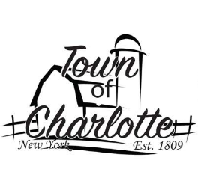
AGENDA
Wednesday, May 10th, 2023
AT THE TOWN OF CHARLOTTE HIGHWAY DEPARTMENT

** ALL TOWN BOARD MEMBERS GIVEN UPDATED MANDATORY EMPLOYEE TRAINING STATUS SHEET **

I. CALL TO ORDER 7:00 PM

II. PRAYER/PLEDGE

III. APPROVE MINUTES

IV. APPROVE VOUCHERS

V. NEW BUSINESS:

OPEN PUBLIC MEETING on the proposed moving funds ($55,000) from the reserve equipment fund to DA5130.2 Machinery – Equipment fund.

DISCUSSION

CLOSE MEETING

ROLL CALL VOTE

1. Report of officers: Highway, Justice, Clerk, Tax Collector, Assessor, Building/Zoning, Dog Control
2. Financial Report
3. Motion: ROA Results for Tax Collector
4. Motion: Set Board of Assessment Review for Wednesday, May 24th from 4pm – 8pm at the Sinclairville Village Hall, 8 Lester Street, Sinclairville.
5. Roof on dugouts at ballfield
6.
7.
8.
9.
10.

ADJOURN

