Ellicottville Engineering Department
28 Parkside Dr. Ellicottville, New York 14731
Phone: (716) 699-9005

REQUEST FOR PROPOSAL

SPECIFICATIONS AND RELATED DOCUMENTS

Landscape Maintenance
Jefferson Street, Niles (Rt.242W) & Bryant Hill Cemeteries

FOR

TOWN OF ELLICOTTVILLE, NY

March 16, 2023

All proposals for the Landscape Maintenance of Jefferson St., Niles (Rt.242W), & Bryant Hill Cemetery, for the Town of Ellicottville Engineering Department, according to specifications, shall be received by the Town & Village Engineer, Ben Slotman, P.E. by Friday March 31, 2023 at 10:00 A.M. at the Office of the Ellicottville Engineering Department at 28 Parkside Dr, Ellicottville, NY 14731.

TABLE OF CONTENTS

Advertisement Page #3

Scope of Work Page #4

Bid Form Page #8

Required Certifications

- Bidders Questionnaire Page #9
- Legal Status Information Page #15
- Non-Collusive Bidding Certification Page #16

Agreements / Contract Requirements Page #17

Attachments (To Be Completed After Award)

- Notice of Award
- Agreement
- Notice to Proceed
- Certificate of Substantial Completion

REQUEST FOR PROPOSALS
The Town of Ellicottville is accepting proposals for the landscape maintenance of the Jefferson Street, Niles (Rt 242W) and Bryant Hill Cemeteries. Specs and information can be obtained from the Town Engineer by calling 716-699-9005 or by email ben.slotman@evlengineering.com .
Sealed bids will be received by the Town of Ellicottville Engineering Department located at 28Parkside Dr, P.O. Box 600, Ellicottville, NY 14731, until 10:00 a.m. Friday March 31, 2023, and then at that time and place opened and read aloud.
The Town reserves the right to accept or reject any and all bids, and to accept the bid, which, in their opinion, meets the intent of the specifications and deemed most advantageous to the Town.
BY ORDER OF THE TOWN OF ELLICOTTVILLE TOWN BOARD
SCOPE OF WORK
- Introduction / Project Background:
This is a Request for Proposals (RFP) for the landscape maintenance of the Jefferson Street, Niles (Rt.242W) and Bryant Hill Cemeteries in the Town of Ellicottville. The properties are 1.75, 1.13, and .13 acres respectively, for a combined total of three (3) acres. The scope of work associated with this RFP is for maintaining the lawn/grassed areas within the cemetery properties. The contractor is expected to perform an initial clean up, mowing, and trimming by May 7th, 2022. Clean up, mowing, and trimming three (3) times per month during the months of May, June, & July. As well as clean up, mowing, & trimming twice (2) per month during the remainder of the contract period (First week of November, 2022). A site map is included in Appendix A.

The intent of this RFP is to secure a contract with a qualified and competent contractor with experience working in the field of landscape maintenance.

ALL PROPOSALS SHALL BE SUBMITTED ELECTRONICALLY TO THE TOWN ENGINEER at ben.slotman@evlengineering.com ON OR BEFORE 10:00 AM PREVAILING TIME ON FRIDAY, MARCH 31, 2023.

The terms of this contract shall be from April 15 through November 1 in any contract year. Payments shall be made on a monthly basis for services provided. The Contractor shall provide a payment schedule with their proposal for the time period of the contract.

New York State Prevailing Wage Rates apply to all work performed under this contract. The Wage Rate Schedule for this project has not been included as part of this RFP, a copy of the Wage Rate Schedule for this project can be requested from the Engineer (PRC #2022000347). The Contractor shall be responsible for complying with any changes to the NYS Prevailing Wage Rate Schedule throughout the project. Certified payroll shall be included with all requests for payment.

- Exiting Utilities:
The Contractor shall field verify the location and availability of existing utilities.
- Site Investigation
Investigate the site to ascertain the general and local conditions that can affect the work or its cost. The site is open to the public for investigation at any time.
- Continuity of Facilities Operation
Schedule work to minimize interference with normal operations.
- Notification of Start and Completion of Work
The Contractor shall notify the Ellicottville Engineering Department (2) days prior to start of work.
- Recycling and Disposal of Refuse
Refuse, excess or waste materials resulting from construction operations shall become the property of the Contractor and shall be recycled and/or disposed of as specified in the Scope of Work. All disposals shall be done in accordance with federal, state, and local laws and regulations.

- Safety
During the execution of this contract, the Contractor shall conform to the rules and regulations as set forth by OSHA Safety and Health Standards, 29 CFR Part 1926 - Safety and Health Regulations for Construction.
- Contractor Identification
Contractor and subcontractor personnel shall, at all times, wear company identification.
- Permits, Licenses, and Insurances
The Contractor shall obtain all appointments, licenses, permits, and insurance required for performance of work and for complying with all applicable Federal, State, and local laws and regulations. Evidence of such permits, licenses, and insurance shall be provided to the Town & Village Engineer upon request.
- Spring Cleanup and Maintenance
1. Cleanup and remove from the property all winter debris, all trash, garbage, cans, papers, leaves, and twigs.
2. Accumulated stones and gravel on all common areas to be raked out, swept out and removed.
3. Rake all dead/damaged turf areas clear of snow mold or dead grass.

- Cutting and Maintenance
- The following work is to be performed each week beginning in May (as soon as turf is dry enough to mow) and ending on or before the first full week of November, depending on weather conditions.
- Cleanup, mowing and trimming to be completed by May 7th, 2023
- Cleanup, mowing and trimming three (3) times per month during the months of May, June, and July
- Cleanup, mowing and trimming, two (2) times per month during the remainder of the contract period (First Week of November, 2023)
- No engine work to start before 8:00 AM.
- Work not to be performed on Sundays or holidays without prior approval of Town Engineer.
- Contractor shall coordinate with the cemetery personal on any special events that take place to work around their needs.
- If rained out, work to be performed on next available day.
- Credit for incomplete work, or work not performed, shall be prorated on the basis of the percentage of the area incomplete with adjustments made in the next payment to Contractor.
- Prior to each mowing, all common areas, turf, road and parking areas shall be cleaned by picking up and removing all trash, garbage, cans, papers, twigs and any other undesirable materials.
- All turf areas shall be mowed once a week to a standard height of 2 1/4” to 2 1/2” except during the heat of summer when mowers are to be raised to 2 3/4” to 3 1/4”.
- Cutting blades must be kept sharp, balanced and evenly adjusted.
- Mowers shall be operated in such a manner as to prevent scalping of high spots so there is an even height of grass over the entire lawn.
- Direction of mowing shall be changed from time to time if possible or requested.
- In the event the ground becomes soft from excessive rain or springs, mowing will be postponed until the ground is firm enough to support equipment without damage. If during this period the grass grows in excess of 3 1/2”, mowing should be done in two stages. All excess clippings to be raked and removed from property. The wet areas must be cut with a walk behind mower (no sulky mowing or standard mowing on wet areas). Contractor shall provide properly sized equipment to professionally cut the areas of the facility.
- All mowers shall utilize baggers or mulching mower blades at all times when mowing.
- Grass clippings and clumps are to be removed from all bed areas, streets, curbs, parking bumpers, sidewalks, patios and entrance ways and are to be removed from the property.
- All tall grass around trees, fences, window wells, behind air conditioning units and drain pipes, signs, buildings, etc., after mowing, shall be trimmed or weed whipped. Do not use “Round-Up” or other herbicides without prior approval.
- A small push mower must be used when cutting between closely set trees and between common beds and grass areas.

NOTE: REMOVAL TO MEAN REMOVAL FROM PROPERTY
- General
- Contractor is responsible for replacing, at his own expense, all plantings damaged during any work on the lawn: flower, shrub and tree beds.
- Contractor is responsible for any damage to all plants or other ornamentation, etc., including those installed by members during work being performed on the lawns, flower beds, shrubs and tree beds. The Contractor is responsible for repairing any damage caused from operating improper equipment on wet areas, including regrading, placing topsoil, seeding, and watering.
- At least one skilled, qualified landscape supervisor will be on-site to supervise the work at all times.
4. Contract area shall be kept free of poison ivy, poison oak.
5. Any special problems noticed, such as insects or disease in the lawn, tree and shrub areas, should be brought to the attention of the Town Engineer. Contractor will advise Town Engineer of possible solution to problem and the cost to remedy same.
6. The methods outlined in this specification should be adequate, however, if contractor has any other recommendations, they should be reported directly to the Town Engineer in writing.
7. A site plan is attached which specifies the contract area.
8. Proof of certification/licensing must be provided whenever there is use of a herbicide/pesticide.
9. It is expected some weeks in summer will not require mowing, we do not encourage the waste of cost by running equipment unnecessarily, however, certain areas (i.e. shaded) may require service and some other service may be substituted.
- Additional Specifications
1. Contractor must furnish his home, office, mobile, and/or pager telephone number to the Town Engineer so he/she can be reached at all times.
2. Contractor is to be properly licensed (if applicable) with the Municipality in which work is to be performed.
- Insurance
Contractor shall in a manner satisfactory to the Town, maintain at its own expense until completion of the work and final payment thereof the following insurance prior to any contracts being signed.

- Workmen's Compensation is required for all contractors working on said property, covering all employees of the contract. The certificate must specify if the Proprietor, Partners, or Executives are included or excluded.
2. Broad form General Liability (Public Liability) insurance in an amount not less than $1,000,000 combined single limit per occurrence; and $2,000,000 general aggregate. Town of Ellicottville is to be listed as additional insured on a primary and non-contributory basis.
3. Automobile Liability, bodily injury and property damage limit of at least $500,000 combined single limit, covering owned, non – owned and hired autos.
4. Description of Operations, must specify the work to be completed and list the Town of Ellicottville as “additional insured” for Commercial General Liability.

TOWN OF ELLICOTTVILLE
LANDSCAPE MAINTAINENCE. JEFFERSON ST., NILES, BRYANT HILL CEMETERIES

Bid Form

Proposal of _____________________________________________________ (hereinafter called "BIDDER"), organized and existing under the laws of the State of _______________________________________________________________________ doing business as________________________________________. To Town of Ellicottville (hereinafter called "OWNER").

BIDDER agrees to perform all the work described in the RFP for the following unit or lump sum prices:

NOTE: The Town of Ellicottville is exempt from sales and compensating use taxes of the State of New York and cities and counties of the State of New York on all materials sold to the Owner. These taxes are not to be included in this Bid.

ITEM | DESCRIPTION | UNITS | QUANITY | UNIT PRICE | TOTAL
1 | Landscape Maintenance | LS | 1
 | TOTAL

TOTAL AMOUNT OF ALL BID PRICES: $
(Number)

(Written)

Respectfully submitted:

Name of the Contractor Street Address

Signature City, State, and Zip

Title Date

License number (if applicable)

SEAL - (if BID is by a Corporation)
BIDDER’S QUESTIONNAIRE

Town of Ellicottville
Landscape Maintenance. Jefferson St., Niles, & Bryant Hill Cemeteries

Submitted By: ________________________________________________________________
Which is:

A Corporation A Co-Partnership An Individual

Principal Office Address:

By filling out this Questionnaire, the Bidder acknowledges that the information contained below is true and accurate.

Part 1 – General Bidder Information

- How many years has your organization been in business as a contractor under your present business name? ____________

- How many years of experience in Landscape Maintenance has your organization had:

(a) As a General Contractor ________ (b) as a Sub-Contractor ________

- What similar projects has your organization completed? (List at least three)

Project:
Type of Work:
Total Construction Cost:
Date of Completion:
Project Owner:
(provide references and
Contact information)

Project:
Type of Work:
Total Construction Cost:
Date of Completion:
Project Owner:
(provide references and
Contact information)

Project:
Type of Work:
Total Construction Cost:
Date of Completion:
Project Owner:
(provide references and
Contact information)

Attach additional information with this Questionnaire if necessary.

- Has your company ever failed to complete any work awarded to you? _________

If so, where and why?

- Has your company been issued a Notice of Termination on any work awarded to you? ________

If so, where and why?

- Has any officer or partner of your organization ever failed to complete a construction contract handled in his own name? _______

If so, state name of individual, name of owner and reason thereof.

- In what other lines of business are you financially interested?

- For what corporations or individuals have you performed work within the last 5 years? (Please provide references)

Project:
Type of Work:
Total Construction Cost:
Date of Completion:
Project Owner:
(provide references and
Contact information)

Project:
Type of Work:
Total Construction Cost:
Date of Completion:
Project Owner:
(provide references and
Contact information)

Project:
Type of Work:
Total Construction Cost:
Date of Completion:
Project Owner:
(provide references and
Contact information)

Attach additional information with this Questionnaire if necessary.

- For what towns, villages or cities have you performed work within the last 5 years? (Please provide references)
Project:
Type of Work:
Total Construction Cost:
Date of Completion:
Project Owner:
(provide references and
Contact information)

Project:
Type of Work:
Total Construction Cost:
Date of Completion:
Project Owner:
(provide references and
Contact information)

Project:
Type of Work:
Total Construction Cost:
Date of Completion:
Project Owner:
(provide references and
Contact information)

Attach additional information with this Questionnaire if necessary.

- What is the landscape maintenance experience of the principal individuals of your organization?
Individual’s Name:
Current Company Position:
Years of Construction Experience:
Types and Magnitude of work completed:

Individual’s Name:
Current Company Position:
Years of Construction Experience:
Types and Magnitude of work completed:

Attach additional information with this Questionnaire if necessary.

Part 2 – Project Specific Questions

Question: | YES | NO
- Does your organization have professional personnel and expertise in landscape maintenance?
- Does your organization have experience with Prevailing Rate and Certified Pay Roll?
- Does your organization carry insurance policies in the amounts noted in the RFP?
- Does your organization have similar projects in size and scope?
- Does your organization have properly sized equipment for completing the proposed work?
- Does your organization have the ability to replace damaged plants, shrubs or trees?
- Does your organization have trained personnel to be able to provide a professional service?

LEGAL STATUS INFORMATION

To facilitate correct drawing and execution of contract, proposer shall supply full information concerning legal status:
FIRM NAME: _______________________________________________________________________
PRINCIPAL OFFICE:

Street

City, State, Zip

Area Code Telephone
LOCAL OFFICE:

Street

City, State, Zip

Area Code Telephone

Website:________________________________

CONTRACT TO BE SENT TO: Principal Office: Local Office:

CHECK ONE: Corporation Partnership Individual

(Incorporated under the Laws of the State of )

(If foreign corporation, state if authorized to do business in the State of New York: Yes No Not Applicable )

TRADE NAME:

NAMES AND ADDRESSES OF PARTNERS:

NAME, TITLE, AND ADDRESS OF PERSON AUTHORIZED TO SIGN CONTRACT ON BEHALF OF PROPOSER:

Name:

Title:

Address:

PLEASE TYPE OR PRINT

NON-COLLUSIVE BIDDING CERTIFICATION

By submission of this Bid, each Bidder and each person signing on behalf of any Bidder certifies, and in the case of a joint Bid each party thereto certifies as to its own organization, under penalty of perjury, that to the best of knowledge and belief:

  - The prices in this Bid have been arrived at independently without collusion, consultation, communication, or agreement, for the purpose of restricting competition, as to any matter relating to such prices with any other bidder or with any competitor;
  - Unless otherwise required by law, the prices which have been quoted in this Bid have not been knowingly disclosed by the Bidder and will not knowingly be disclosed by the Bidder prior to opening, directly or indirectly, to any other Bidder or to any competitor; and
  - No attempt has been made or will be made by the Bidder to induce any other person, partnership or corporation to submit or not to submit a Bid for the purpose of restricting competition.

Resolved that (Name of Corporation Officer) be authorized to sign and submit the Bid or proposal of this corporation for any or all phases of the following project:

Town of Ellicottville
Landscape Maintenance, Jefferson St., Niles, Bryant Hill Cemeteries

And to include in such Bid or proposal the certificate as to non-collusion required by Section one hundred three-d of the General Municipal Law as the act and deed of such corporation, and for any inaccuracies or misstatements in such certificate this corporate Bidder shall be liable under the penalties of perjury.
---------------------------------------------------------------------------------------------------------------

The foregoing is a true and correct copy of the resolution adopted by
(Corporation)
at a meeting of its Board of Directors held on .
(Date)

Affix Corporate Seal Secretary
RESPECTFULLY SUBMITTED,

BY:
Name & Address of Bidder

Signature & Title of Authorized Officer

Date

AGREEMENTS / CONTRACT REQUIREMENTS

    - BID DEPOSIT:
For a bid amount of $15,000 or LESS a certified check for Five Hundred dollars ($500) must be submitted with the bid. For a bid amount GREATER than $15,000 a BOND or certified check for ten percent (10%) of bid amount must be submitted with the bid. The undersigned agrees that the bid security may be retained by the Town of Ellicottville until contracts have been signed and Performance Bonds have been delivered to the Town of Ellicottville. Should the successful bidder to whom the bid is awarded fail to execute the agreement submitted by the Town of Ellicottville in accordance with the formal bid and other contract documents and to furnish the required performance bond within fourteen (14) calendar days after the notice of award, the certified check or the bid bond amount shall be forfeited to the Town of Ellicottville as liquidated damages caused by such failure.

    - PERFORMANCE BOND.
The successful bidder or bidders shall, within two weeks after notice of the award, enter into a contract with the Town of Ellicottville and furnish a performance bond running to the Town of Ellicottville in the amount of zero percent (0%) of bid amount, which will be retained until completion of the contract. The Performance Bond must be in a format acceptable to the Town of Ellicottville Attorney.

    - BID FORM.
Bid shall be submitted on these Town of Ellicottville bid forms or bid will not be considered. Bid must be typed or printed in ink. Original autograph signatures in ink are required. Facsimile or rubber stamp signatures will not be accepted.

    - CHANGES.
Any change in wording or interlineation by a bidder of the inquiry as published by Town of Ellicottville shall be reason to reject the proposal of such bidder, or in the event that such change in the Invitation to Bid is not discovered prior to entering into a contract, to void any contract entered into pursuant to such bid.

    - INFORMALITIES.
The Town of Ellicottville may consider informal any bid not prepared and submitted in accordance with the provisions hereof & may waive any informalities or reject any and all bids. The contract award will be made to the responsible bidder submitting the lowest acceptable bid. Conditional bids will not be accepted.
    - BID TIME.
Any bid may be withdrawn prior to the above scheduled time for the opening of bids, or authorized postponement thereof. Any bid received after the time specified shall not be considered.

    - INVESTIGATIONS.
The Town of Ellicottville may make such investigations as it deems necessary to determine the ability of the bidder to perform the work, and the bidder shall furnish to the Town of Ellicottville all such information and data for this purpose as the Town of Ellicottville may request. The Town of Ellicottville reserves the right to reject any bid if the evidence submitted by, or investigation of, such bidder fails to satisfy the Town of Ellicottville that such bidder is properly qualified to carry out the obligations of the contract and to complete the work contemplated therein.

    - NON-COLLUSIVE CERTIFICATION.
Non-collusive bidding certification shall be made by each bidder in the form provided and shall be submitted as a part of the bid. Bids submitted without non-collusive bidding certification will be considered irregular and may be rejected by the Town of Ellicottville.

    - CONTRACT AWARD.
Contract(s) or purchase order(s) will be awarded after due consideration of the suitability of goods and/or services bid to satisfy these specifications, the total cost of such goods and/or services including all cost elements, and the timeliness of the agreed upon delivery date.

    - EXECUTORY CLAUSE.
This EXECUTORY CLAUSE shall be a part of any agreement entered into pursuant to this bid: It is understood by the parties that this agreement shall be executory only to the extent of the monies available to the Town of Ellicottville and appropriated therefore, and no liability on account thereof shall be incurred by the Town of Ellicottville beyond the monies available and appropriated for the purpose thereof.

    - PRICES.
Prices shall be quoted F.O.B. destination, delivered inside and installed, or as otherwise specified in the specifications. "Tailgate Delivery" will not be accepted unless specified by the Town of Ellicottville.

    - TRANSPORTATION CHARGES.
Collect transportation charges will not be paid by the Town of Ellicottville. All freight, cartage, rigging, postage or other transportation charges shall be prepaid.

    - TAXES.
No taxes are to be billed to the Town of Ellicottville. Bid shall not include any Federal, State, or local excise, sales, transportation, or other tax unless Federal or State law specifically levies such tax on purchases made by a political subdivision. Any applicable taxes from which the Town of Ellicottville is not exempt shall be listed separately as cost elements, and added into the total net bid.

    - COMPLIANCE WITH LAWS.
The successful bidder shall comply with all laws, rules, regulations and ordinances of the Federal Government, the State of New York and any other political subdivision or regulatory body which may apply to its performance under this contract.

HAZARD COMMUNICATION In complying with the above laws, rules and regulations, and pursuant to 12 NYCRR part 820 and Section 876 of the Labor Law, it is the responsibility of the Town of Ellicottville to provide the successful bidder with the following information:

- The material safety data sheets (MSDS) for any hazardous chemicals to which employees may be exposed will be made available.
- The telephone numbers of plant personnel who are to be contacted in the event of a chemical spill or accident and
- emergency procedures in the event of a fire or spill.
MATERIAL SAFETY DATA SHEETS. The successful bidder shall be responsible for the provision of the MSDSs to the Town of Ellicottville prior to introducing hazardous materials onto the site, ensuring compliance before work is started and disseminating any information to the Town of Ellicottville employees concerning significant chemical hazards that the successful bidder is bringing to the Village of Ellicottville 's workplace. the MSDSs will be obtained from the successful bidder for all hazardous materials prior to bringing the materials on the site. these MSDSs will be maintained be the Town of Ellicottville as long as those materials are present. It is the responsibility of the successful bidder to train its own employees.

    - CONTRACT ASSIGNMENTS.
The bidder shall not assign, transfer, sublet, or otherwise dispose of this contract, or of its right, title or interest in the contract, or its power to execute the same, to any other person or corporation without the previous consent, in writing, of the Town of Ellicottville Supervisor.

    - CASH DISCOUNT.
ANY CASH DISCOUNT which is a part of a bid will be considered as a reduction in the bid prices in determining the award of the bid. Date of invoice must not precede date of delivery. The Town of Ellicottville policy is to pay all claims in a timely manner within the specified time. However, if for some reason payment is delayed, the Town of Ellicottville will take the discount when payment is made. If this is unsatisfactory, please quote net. The Town of Ellicottville will not pay any interest charges.

    - ALTERNATE ITEMS.
If material or services other than those specified in this bid document are offered, the bidder must so state and
furnish at the time of bid opening, if so requested, and as part of his bid the following information in duplicate:
      - Complete description of the item offered, and detailed explanation of the differences between the item specified and the item offered. If, in the opinion of the Department Head, sufficient detail is not presented as a part of the sealed bid to permit definite evaluation of any substitute item, the bid will not be considered.
      - Descriptive literature of item offered, for evaluation.
      - List of installations in Town of Ellicottville of the item offered.
      - List of other installations.

    - ADDITIONAL INFORMATION.
Any additional information which bidder desires to add to the bid shall be written on a separate sheet of paper, attached to and submitted with the formal sealed bid, to be read at the formal opening.

    - WORKMANSHIP.
Workmanship must meet with the approval of the department head or heads involved, and shall be first class in every respect without exception and shall be equal to the best modern practices. Materials furnished are to be new and unused. All materials furnished or work performed are to be guaranteed free from defects. Anything found defective or not meeting specifications, no matter in what state of completion, may be rejected and shall be made good by the contractor at his own expense.

    - HOLD HARMLESS.
The successful bidder to whom the bid is awarded shall indemnify and hold harmless Town of Ellicottville and its agents and employees from and against all claims, damages, losses or causes of action arising out of or resulting from such vendor's performance pursuant to this bid.

    - BID VALIDITY.
This bid is firm and irrevocable for a period of 45 days from the date and time of the bid opening. If a contract is not awarded within the 60 day period, a bidder to whom the bid has not been awarded, may withdraw his bid by serving written notice of his intention to do so upon the Clerk of the Town of Ellicottville. Upon withdrawal of the bid pursuant to this paragraph, the Town of Ellicottville will forthwith return the bidder's security deposit.

    - CONTRACT INTEREST.
No official, or employee of the Town of Ellicottville, who is authorized in such capacity, and on behalf of the Town of Ellicottville, to negotiate, make, accept or approve or to take part in negotiating, making, accepting, or approving this contract shall become directly or indirectly interested personally in this contract or in any part hereof. No officer or employee of, or for the Town of Ellicottville, who is authorized in such capacity, and on behalf of the Town of Ellicottville, to exercise any supervisory, administrative, or other function, in connection with this contract, shall become directly or indirectly interested personally in this contract or in any part hereof.

    - OTHER CUSTOMERS.
Prices charged to Town of Ellicottville are to be no higher than those offered to any other governmental or commercial consumer. If a bidder has a New York State or a Federal GSA

contract for any of the items covered in this bid or any similar items, he shall so indicate that he has said contract on these bid papers and supply a copy of this contract within 5 days if so requested by the Town of Ellicottville.

    - PRICE IS FIRM.
The unit prices bid shall remain firm, and any other charges bid shall also remain firm, for delivery of the equipment, material, work, or services described in this bid. No cost increase shall be charged for any reason whatsoever.

    - BIDDER AFFIRMATION.
In executing this bid, the bidder affirms that all of the requirements of the specifications are understood and accepted by the bidder, and that the prices quoted include all required materials and services. The undersigned has checked all of the bid figures, and understands that the Town of Ellicottville will not be responsible for any errors or omissions on the part of the undersigned in preparing this bid. Mistakes or errors in the estimates, calculations, or preparation of the bid shall not be grounds for the withdrawal or correction of the bid or bid security. In case of error in extension of prices in the bid, the unit price will govern.

    - CALCULATION OF PURCHASE PRICE
When calculating the purchase price, list on the individual bid forms the TOTAL cost of each unit.

    - INSURANCE
The (Contractor, Vendor, Etc.) shall secure and maintain, at its own cost and expense, insurance coverage complying with Classification "(selected on form)", with insurance companies licensed in the State of New York. The Town of Ellicottville must be named as an additional insured for purposes of coverage, but not for payment of premium. The (Contractor, Vendor, Etc.) shall file a certificate of insurance with the Town of Ellicottville covering all acts performed by the (Contractor, Vendor, Etc.) prior to performing pursuant to this Agreement or receiving any payment thereunder and shall be responsible for updating the certificate as necessary throughout the term of the Agreement. All certificates of insurance shall provide that Town of Ellicottville be given thirty (30) days’ notice prior to non-renewal or cancellation of these policies. Certificate of Insurance shall be furnished by the bidder within five (5) days of the “Intent to Award” and prior to signing of contract. Failure to supply a satisfactory certificate within five (5) days after the “Intent to Award” may result in the cancellation of award and for the forfeiture of the Contractor’s bid security, in the sole discretion of the Town of Ellicottville
Notice of Award

Project: |  | Owner: | Town of Ellicottville
Contract: | Landscape Maintenance. Jefferson St., Niles, & Bryant Hill Cemeteries
Bidder:
Bidder's Address:

The OWNER has considered your BID dated , submitted by you in response to its Advertisement for Bids and the Instructions To Bidders, for the above described WORK.

You are hereby notified that your BID has been accepted for the Contract Price of $ .

You are required by the Instructions for Bidders to execute the Agreement, and to furnish the required Bonds and Certificate(s) of Insurance within ten (10) days from the date of this Notice (noted at top).

If you fail to execute said Agreement, and to furnish said Bonds and Certificate(s) of Insurance within ten (10) days from the date of this Notice, said OWNER will be entitled to consider all your rights arising out of the OWNER's acceptance of your BID as abandoned, and may annul the Notice of Award, and consider forfeiture of your Bid Security. The OWNER will be entitled to such other rights as may be granted by law.

You are required to return an acknowledged copy of this Notice of Award to the OWNER.

Dated this the day of ___ , 2023.

Town of Ellicottville

By___ ____________________

Title – Ellicottville, NY

ACCEPTANCE OF NOTICE:

Contractor
By:
Authorized Signature

Title

Date
Ellicottville Engineering Department
28 Parkside Dr. Ellicottville, New York 14731
Phone: (716) 699-9005

AGREEMENT BETWEEN
TOWN OF ELLICOTVILLE
AND CONTRACTOR FOR
LANDSCAPE MAINTENCE CONTRACT

THIS AGREEMENT is by and between Town of Ellicottville (Owner)

and __________ (Contractor).

Owner and Contractor, in consideration of the mutual covenants set forth herein, agree as follows:

ARTICLE 1 - WORK

1.01 Contractor shall complete all Work as specified or indicated in the Contract Documents. The Work is generally described as follows:
This is a Request for Proposals (RFP) for the landscape maintenance of the Jefferson Street, Niles (Rt.242W) and Bryant Hill Cemeteries in the Town of Ellicottville. The properties are a combined total of 3 acres. The scope of work associated with this RFP is for maintaining the lawn/grassed areas within the cemetery properties. The contractor is expected to perform an initial clean up, mowing, and trimming by May 7th, 2022. Clean up, mowing, and trimming three (3) times per month during the months of May, June, & July. As well as clean up, mowing, & trimming twice (2) per month during the remainder of the contract period (First week of November, 2022). A site map is included in Appendix A.

1.02 Contractor shall complete all other work, not necessarily described in the Contract Documents, but as may be directed by the Owner, to be included as part of the Work, to included but not limited to, all work authorized by Change Order(s), and all other Work determined by the Owner to be necessary and required, as directed by the Owner.

ARTICLE 2 - THE PROJECT

2.01 The Project for which the Work under the Contract Documents may be the whole or only a part is generally described as follows:
Town of Ellicottville
Landscape Maintenance. Jefferson St., Niles, & Bryant Hill Cemeteries

ARTICLE 3 - CONTRACT TIMES

3.01 The Work will be substantially completed by the first week of November, 2023.
3.02 Liquidated Damages

A. Contractor and Owner recognize that time is of the essence of this Agreement and that Owner will suffer financial loss if the Work is not substantially completed within the times specified in Paragraph 3.01 above, plus any extensions thereof agreed to. Failure to complete work and make delivery of materials within the stated time period shall result in a notification to the Contractor and the beginning of a 5 Working Day Grace Period. Failure to deliver with the Grace Period will result in a penalty of 1% of the Contract Price on a per day basis from the date of notification and/or cancellation of Contract.

ARTICLE 4 - CONTRACT PRICE

4.01 Owner shall pay Contractor for completion of the Work in accordance with the Contract Documents an amount in current funds equal to the sum of the amounts determined pursuant to Paragraph 4.01.A. All specific cash allowances are included in the prices and have been computed in accordance with the Contract Documents

A. The CONTRACTOR agrees to perform all of the WORK described in the CONTRACT DOCUMENTS and comply with the terms therein for the sum of $ __ ______ , or as shown in the Bid Sheet.

B. CONTRACTOR shall submit a voucher, certified payroll, and invoice for payment to the Owner on a monthly basis in a form acceptable to the Town Engineer based on an acceptable payment schedule provided by the CONTRACTOR for the time period of the contract.

ARTICLE 5 – CONTRACTOR’S REPRESENTATIONS

5.01 In order to induce Owner to enter into this Agreement Contractor makes the following representations:

A. Contractor has examined and carefully studied the Contract Documents and the other related data identified in the Bidding Documents.

B. Contractor has visited the Site and become familiar with and is satisfied as to the general, local, and Site conditions that may affect cost, progress, and performance of the Work.

C. Contractor is familiar with and is satisfied as to all federal, state, and local Laws and Regulations that may affect cost, progress, and performance of the Work.

D. Contractor is aware of the general nature of work to be performed by Owner and others at the Site that relates to the Work as indicated in the Contract Documents.

E. Contractor has given Engineer written notice of all conflicts, errors, ambiguities, or discrepancies that Contractor has discovered in the Contract Documents, and the written resolution thereof by Engineer is acceptable to Contractor.

F. The Contract Documents are generally sufficient to indicate and convey understanding of all terms and conditions for performance and furnishing of the Work.

ARTICLE 6 – CONTRACT DOCUMENTS

6.01 Contents

- The Contract Documents consist of the following:
  - This Agreement
  - The Request for Proposal
  - Contractors Bid

ARTICLE 7 - MISCELLANEOUS

7.01 Assignment of Contract

A. The CONTRACTOR shall not assign, transfer, convey, or otherwise dispose of this Contract, or any portion thereof, or of its right, title, or interest therein, or its power to execute such Contract, to any other person or corporation without the previous consent in writing of the OWNER.

B. The provisions of this Section shall not hinder, prevent, or affect an assignment by the CONTRACTOR for the benefit of creditors made pursuant to law, nor is it intended to prohibit subcontracting a portion of the Work of the Contract in accordance with the provisions of the law, and this Contract.

7.02 Successors and Assigns

A. Owner and Contractor each binds itself, its partners, successors, assigns, and legal representatives to the other party hereto, its partners, successors, assigns, and legal representatives in respect to all covenants, agreements, and obligations contained in the Contract Documents.

7.03 Severability

A. Any provision or part of the Contract Documents held to be void or unenforceable under any Law or Regulation shall be deemed stricken, and all remaining provisions shall continue to be valid and binding upon Owner and Contractor, who agree that the Contract Documents shall be reformed to replace such stricken provision or part thereof with a valid and enforceable provision that comes as close as possible to expressing the intention of the stricken provision.

IN WITNESS WHEREOF, Owner and Contractor have signed this Agreement. One counterpart each has been delivered to Owner, Contractor, Town Engineer. All portions of the Contract Documents have been signed, initialed, or identified by Owner and Contractor or identified by the Town Engineer on their behalf.

This Agreement will be effective which is the Effective Date of the Agreement. This Agreement shall not be effective unless and until Agency’s designated representative concurs.

OWNER: |  |  |  |  |  |  |  |  |  |  |  |  |  | CONTRACTOR:
Town of Ellicottville
P.O. Box 600
Ellicottville, New York 14731
By: |  |  |  |  |  |  |  |  |  |  |  |  |  | By:
Title: |  | Town Supervisor |  |  |  |  |  |  |  |  |  |  |  | Title:
[CORPORATE SEAL] |  |  |  |  |  |  |  |  |  |  |  |  |  | [CORPORATE SEAL]
Attest: |  |  |  |  |  |  |  |  |  |  |  |  |  | Attest:
Title: |  |  |  |  |  |  |  |  |  |  |  |  |  | Title:
Designated Representatives: |  |  |  |  |  |  |  |  |  |  |  |  |  | Designated Representatives:
Name: |  |  | Ben Slotman. P.E. |  |  |  |  |  |  |  |  |  |  | Name:
Title: |  |  | Town Engineer |  |  |  |  |  |  |  |  |  |  | Title:
Address for giving notices: |  |  |  |  |  |  |  |  |  |  |  |  |  | Address for giving notices:
P.O. Box 600
One West Washington St.
Ellicottville, NY 14731
Phone: |  |  |  | (716) 699-9005 |  |  |  |  |  | FAX: |  |  |  | Phone: |  |  |  |  |  |  |  |  |  | FAX:
 |  |  |  |  |  |  |  |  |  |  |  |  |  | License No.:
(If Owner is a corporation, attach evidence of authority to sign. If Owner is a public body, attach evidence of authority to sign and resolution or other documents authorizing execution of Owner-Contractor Agreement.) |  |  |  |  |  |  |  |  |  |  |  |  |  |  |  |  |  |  | (Where applicable)
 |  |  |  |  |  |  |  |  |  |  |  |  |  | Agent for service or process:
 |  |  |  |  |  |  |  |  |  |  |  |  |  | (If Contractor is a corporation or a partnership, attach evidence of authority to sign.)

Appendix A
Site Map

Jefferson Street Cemetery
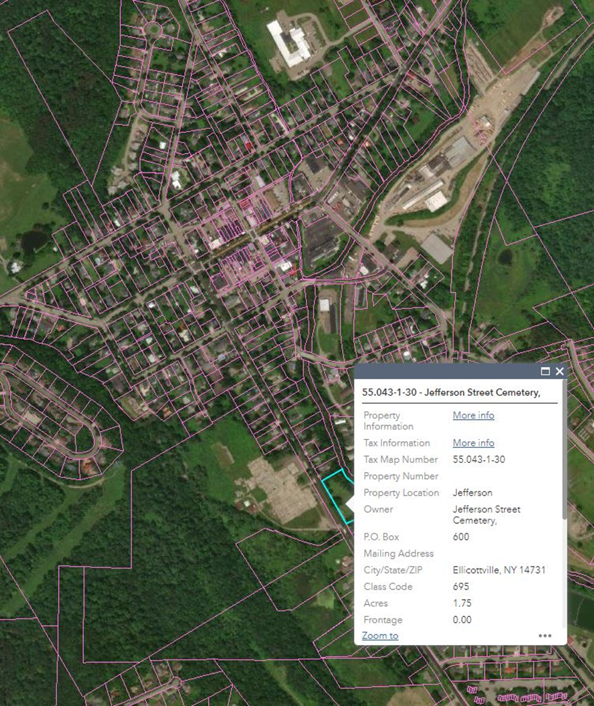

Niles (Rt.242W) Cemetery
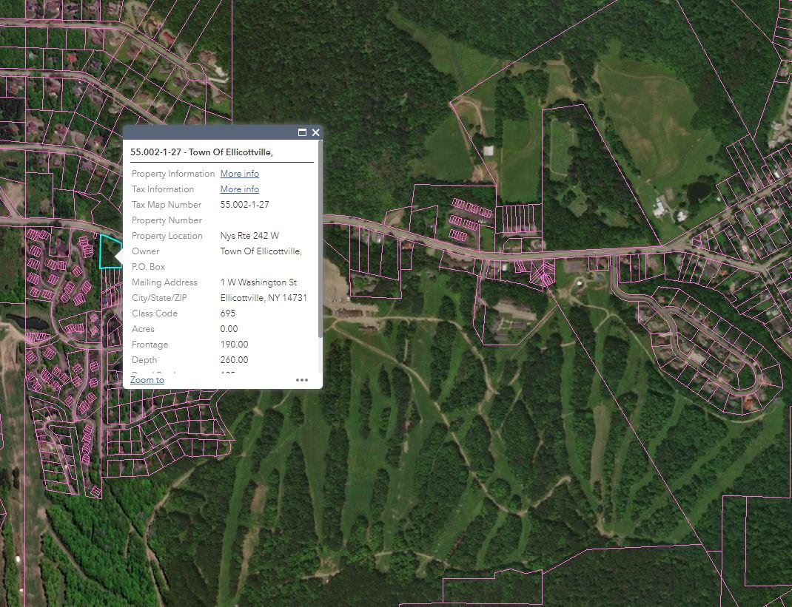

Bryant Hill Cemetery
