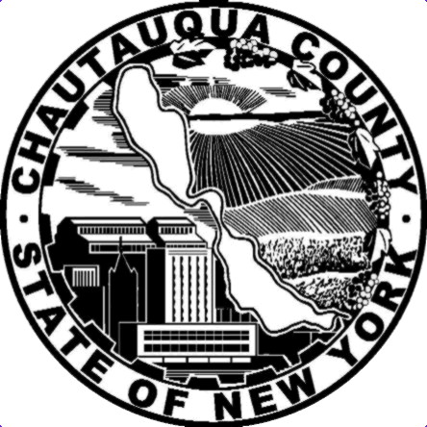 CHAUTAUQUA COUNTY

DEPARTMENT OF HEALTH AND HUMAN SERVICES
PAUL M. WENDEL, JR. CHRISTINE SCHUYLER
County Executive Director
(Commissioner of Social Services/Public Health Director)

Tuesday, July 12, 2022

Town of Ripley

14 N. State St

Ripley, N.Y. 14775

RE: 2022 Youth Bureau Grant

Dear Mr. Michael Rowe:

The 2022 Youth Bureau grant process has been completed and the recommendations have been approved. This letter is to notify you that Chautauqua County Youth Bureau will be funding the Summer Youth Recreation Program in amount of $1,500.00. We value your agency for your commitment to serve our youth and the families.

The Chautauqua County Youth Board and Youth Bureau recommendations for the 2022 allocations are based on multiple factors including, but not limited to, Rubric Score, the agencies program design, program hours, measurable performance outcomes, development of youth, site monitors, trainings for staff that collaborations promote the safety and well-being of youth, other funding resources., It is our hope that we continue to collaborate initiatives for youth and families in the county and maintain our close relationship.

Very truly,

Patricia Yokom

Patricia Yokom
Program Coordinator: Youth Bureau
Chautauqua County Youth Bureau

Sue Drago
Chairperson: Youth Board

