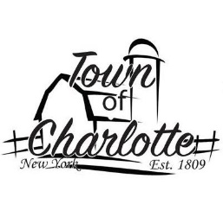 TOWN OF CHARLOTTE
2022 TOWN BOARD MEETINGS
ALL MEETING START AT 7:00 PM
Sinclairville Volunteer Fire Dept Town Highway Garage
30 Main St., Sinclairville 7058 Rood Rd., Sinclairville

February 9 April 13
March 9 May 11
June 8
November 2 July 13
December 14 august 10 September 14
October 3 *Monday

