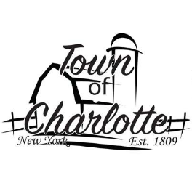
AGENDA
Wednesday, April 12th, 2023
AT THE TOWN OF CHARLOTTE HIGHWAY DEPARTMENT

I. CALL TO ORDER 7:00 PM

II. PRAYER/PLEDGE

III. APPROVE MINUTES

IV. APPROVE VOUCHERS

V. NEW BUSINESS:

1. Report of officers: Highway, Justice, Clerk, Tax Collector, Assessor, Building/Zoning, Dog Control
3. Financial Report
4. Roll Call Vote: Regarding Local Law #1-2023 “A Local Law Enacting the Residential Real Property Partial Tax Exemption for Fire Fighters”
5.
6.
7.
8.
9.
10.

ADJOURN

