April 5, 2022

At 7:00 PM, Mayor Stumpf called the meeting to order.

The following were present:
John Stumpf Mayor
Trustee Patricia Sherwood Trustee
Trista Reisdorf Trustee
Brandon Stearns Trustee
Darwin Dominessy Trustee

Clerk Marcia Lexer

OTHERS PRESENT: Superintendent of Public Works Daren Smith, 1st Assistant Jeff Holmes, EMS Captain Chris Hazeltine and Arcade Herald reporter Anderson Miles.

MINUTES

Trustee Reisdorf seconded by Trustee Dominessy moved suspension of the reading of the Minutes of the previous board meetings of February 8, 2022, March 1, 2022 and March 15, 2022 inasmuch as Board members had been supplied copies. Carried. Mayor Stumpf announced that corrections and alterations would then be heard, and concluding there were none, the minutes stand approved. Carried.

#374 PUBLIC HEARING

At 7:00 PM, Mayor Stumpf opened the Public Hearing on the Budget. No one was in attendance from the Village requesting to speak but reporter Anderson Miles questioned the Recreation portion of the budget.

At 7:13 PM it was moved by Trustee Stearns, seconded by Trustee Sherwood to close the Public Hearing on the budget.

Trustee Dominessy, Trustee Reisdorf aye, Trustee Sherwood aye, Trustee Stearns aye, Mayor Stumpf aye. 5 ayes, 0 nays, 0 absent. Carried.

#375 ORGANIZATION OF THE BOARD

It was moved by Trustee Sherwood, seconded by Trustee Dominessy to approve Mayor Stumpf’s appointments, and pass the following resolutions:

APPOINTMENTS

Deputy Mayor Patricia Sherwood
Village Clerk Marcia Lexer
Treasurer Diane Finch
Village Attorney Peter Sorgi
Constable Joseph Neamon
Dog Control Officer Joseph Neamon
Registrar Donna Lavery
Building Inspector Christopher Lexer
Zoning Officer Christopher Lexer
Historian Jacqueline Cornwall
Keeper of the Clock Brandon Stearns
Official Depository Five Star Bank
Official Newspaper Arcade Herald, Inc.
Crossing Guard John Perrington
Crossing Guard Kathy Norton

RECREATION COMMITTEE

Jack Stumpf Brandon Stearns

COMMITTEES

Fire Department Trustees Sherwood & Stearns
Legal Mayor Stumpf
Parks Trustees Reisdorf & Sherwood
Refuse Disposal Trustees Stearns & Dominessy
Street Lights Trustees Sherwood & Reisdorf
Trees Trustees Stearns & Dominessy

Water Department Trustees Sherwood & Stearns
Youth Recreation Mayor Stumpf & Trustee Stearns
Building Inspector Mayor
Zoning Officer Mayor
Streets & Sidewalks Trustees Dominessy & Reisdorf
Constable Mayor

ORGANIZATION MEETING RESOLUTIONS

The Board of Trustees shall meet the first Tuesday of each month at 7:00 PM in the Delevan Municipal Building for the purpose of conducting official business. Work Sessions to be scheduled as needed.

INVESTMENT POLICY
The Board of Trustees of the Village of Delevan adopt the investment policy, which was passed on April 6, 1993.

ADVANCE APPROVAL OF CLAIMS
RESOLVED: that the Board of Trustees of the Village of Delevan adopt the claim policy which was passed on April 3, 2001, including attendance at municipal meetings and training.

CLAIMANTS CERTIFICATION

The Village Board will not require claimants certification signatures if there is a bill of sale or invoice (statement) for merchandise delivered to the Village.

MILEAGE ALLOWANCE

WHEREAS: the Board of Trustees has determined to pay a fixed rate for mileage as reimbursement to officers and employees of the Village who use their personal automobiles while performing their official duties on behalf of the Village.
NOW THEREFORE BE IT RESOLVED: that the Board of Trustees shall approve reimbursement to such officers and employees at the rate of 40 cents per mile.

ESTABLISHING HOURLY RATE

The hourly rate during the 2022-2023 fiscal year is hereby established at $14.25 per hour for a part-time laborer and $13.90 for the cleaning person.

ANNUAL REVIEW OF PURCHASING POLICY
RESOLVED: that the Board of Trustees of the Village of Delevan adopt the purchasing policy which was passed on April 2, 2002 and amended on February 16, 2010 to include small, minority or women-owned businesses.

ATTENDANCE AT ASSOCIATION MEETINGS

After review of the Association Meetings Policy adopted in 2001, it was agreed upon that the policy should remain the same.
Trustee Dominessy, Trustee Reisdorf aye, Trustee Sherwood aye, Trustee Stearns aye, Mayor Stumpf aye. 5 ayes, 0 nays, 0 absent. Carried.

REPORTS

Fire Department report presented by 1st Assistant Jeff Holmes:

EMS CALLS STRUCTURE FIRES
Village 19 Yorkshire 01
Town of Yorkshire 05 Machias 01

Yorkshire 01 AUTO ACCIDENTS
Village 01

Yorkshire 01

There were 29 calls for the month of March. The Election Nomination list was presented.

Fire Department Applications were presented for Gina Wright and Kevin Woloszyn.

#376 FIRE DEPARTMENT APPLICATIONS

It was moved by Trustee Dominessy, seconded by Trustee Reisdorf to approve the applications of Gina Wright and Kevin Woloszyn.

Trustee Dominessy, Trustee Reisdorf aye, Trustee Sherwood aye, Trustee Stearns aye, Mayor Stumpf aye. 5 ayes, 0 nays, 0 absent. Carried.

Mayor Stumpf said that every board member received a letter of fire department members’ concerns. Discussion ensued about answering calls and the low turnout rate.

#377 BALLOT

The 2022 Fire Department Elections List was presented to the Village Board

It was moved by Trustee Stearns, seconded by Trustee Reisdorf to approve the Ballot.

Trustee Dominessy, Trustee Reisdorf aye, Trustee Sherwood aye, Trustee Stearns aye, Mayor Stumpf aye. 5 ayes, 0 nays, 0 absent. Carried
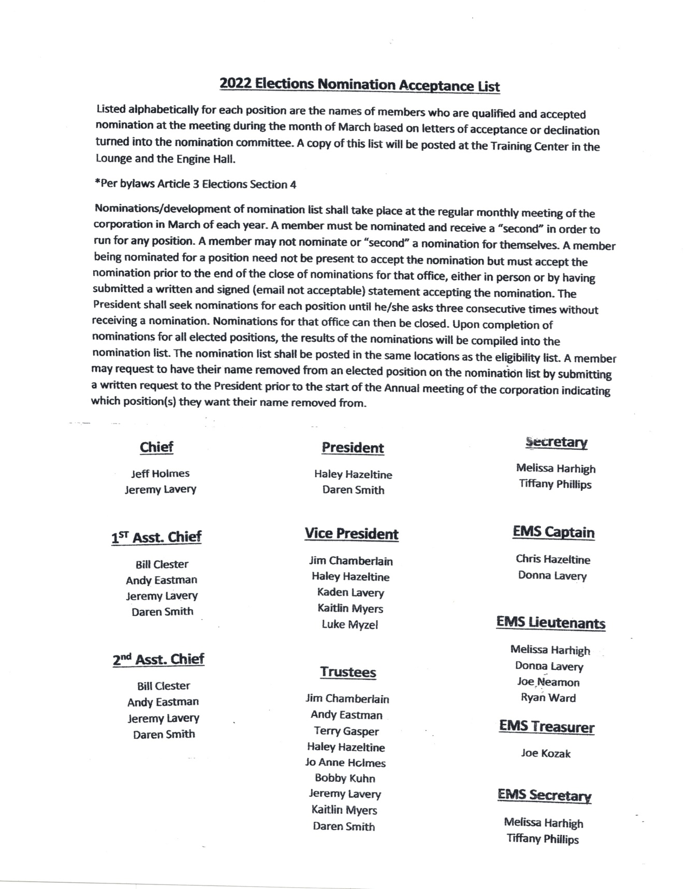

Superintendent of Public Works Daren Smith reported the following:
- Plowing – backed off on some plowing due to turning to ice
- Patching holes
- Filled in for both crossing guards
- Four signs need replacing
- List for brush pickup – starting 04/25 – twice a month; second Monday of every month
- Water – finished reading meters in pits that thawed
- Water meters in vacant building, froze and broke
- Sent agreement to Master meter; checking on whether they will replace frozen meters.
- Received application for Water tap (Fleck) $500 tapping fee

#378 WATER TAP

It was moved by Trustee Stearns, seconded by Trustee Sherwood to approve the tap for Fleck’s at $500.
Trustee Dominessy aye, Trustee Reisdorf aye, Trustee Sherwood aye, Trustee Stearns aye, Mayor Stumpf aye. 5 ayes, 0 nays, 0 absent. Carried.

Clerk Marcia Lexer reported the following:
- Prepared Vouchers and Abstract
- Cash receipts provided to each board member
- Delivered trash stickers to Crosby’s
- Working more in the office to get everything caught up after being off work
- Returned taxes received $5721.69
- Delinquent water – will not be putting them on taxes due to not having all the water meters read.

NEW BUSINESS

- New Water billing – $32326.65, past due water of $17679.49 plus penalties of $2314.86, and past due other of $2251.85; new other of $2848.00 and Grove street of $468.70.
- Meeting Room – discussion ensued, tabled until next month’s meeting.
- Budget

#379 RESOLUTION TO ADOPT THE 2022-2023 BUDGET

The following resolution was moved by Trustee Dominessy, seconded by Trustee Sherwood:

WHEREAS: the Tentative Budget for the year 2022-2023 has been presented to the Board and an advertised Public Hearing was held.

NOW THEREFORE BE IT RESOLVED: that the said tentative budget be and hereby is adopted as the budget of the Village of Delevan for the year 2022-2023 with a tax rate of 18.891602 mils per thousand.

Trustee Dominessy aye, Trustee Reisdorf aye, Trustee Sherwood aye, Trustee Stearns aye, Mayor Stumpf aye. 5 ayes, 0 nays, 0 absent. Carried.

PAY CLAIMS
The bills for the previous month of March were presented and audited. It was moved by Trustee Stearns seconded by Trustee Sherwood to make payment of $21,719.99 Abstract #11, $19,628.74 in General Fund Claims and $2,091.25 in payment of Water Fund Claims.

Trustee Dominessy aye, Trustee Reisdorf aye, Trustee Sherwood aye, Trustee Stearns aye, Mayor Stumpf aye. 5 ayes, 0 nays, 0 absent. Carried.

ADJOURNMENT

At 8:15 PM it was moved by Trustee Dominessy, seconded by Trustee Reisdorf to adjourn. Carried.

Village Clerk Marcia Lexer

