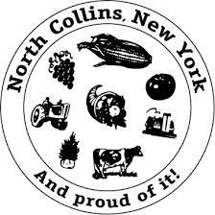

The North Collins Town Board
Will be holding a
BUDGET WORK SESSION
on
Wednesday, September 26th, 2023 at 7pm
At the North Collins Town Hall
All meetings are open to the public.

Lynn DiVincenzo
Town Clerk

